**EXP NO: 7: 16-BIT MULTIPLICATION**  
  
**AIM:**To write an assembly language program to  
implement 16-bit multiplication using 8085 processor.  
  
**ALGORITHM:**  
1)      Load  
the first data in HL pair.  
2)      Move  
content of HL pair to stack pointer.  
3)      Load  
the second data in HL pair and move it to DE.  
4)      Make  
H register as 00H and L register as 00H.  
5)      ADD  
HL pair and stack pointer.  
6)      Check  
for carry if carry increment it by 1 else move to next step.  
7)      Then  
move E to A and perform OR operation with accumulator and register D.  
8)      The  
value of operation is zero, then store the value else go to step 3.  
  
  
**PROGRAM:**  
 LHLD 2050  
 SPHL  
 LHLD 2052  
XCHG  
 LXIH,0000H  
 LXIB,0000H  
AGAIN: DAD SP  
 JNC  
START  
INX B  
START: DCX D  
 MOV A,E  
ORA D  
 JNZ  
AGAIN  
 SHLD 2054  
MOV L,C  
 MOV H,B  
SHLD 2056  
HLT  
  
  
  
  
  
**INPUT:**

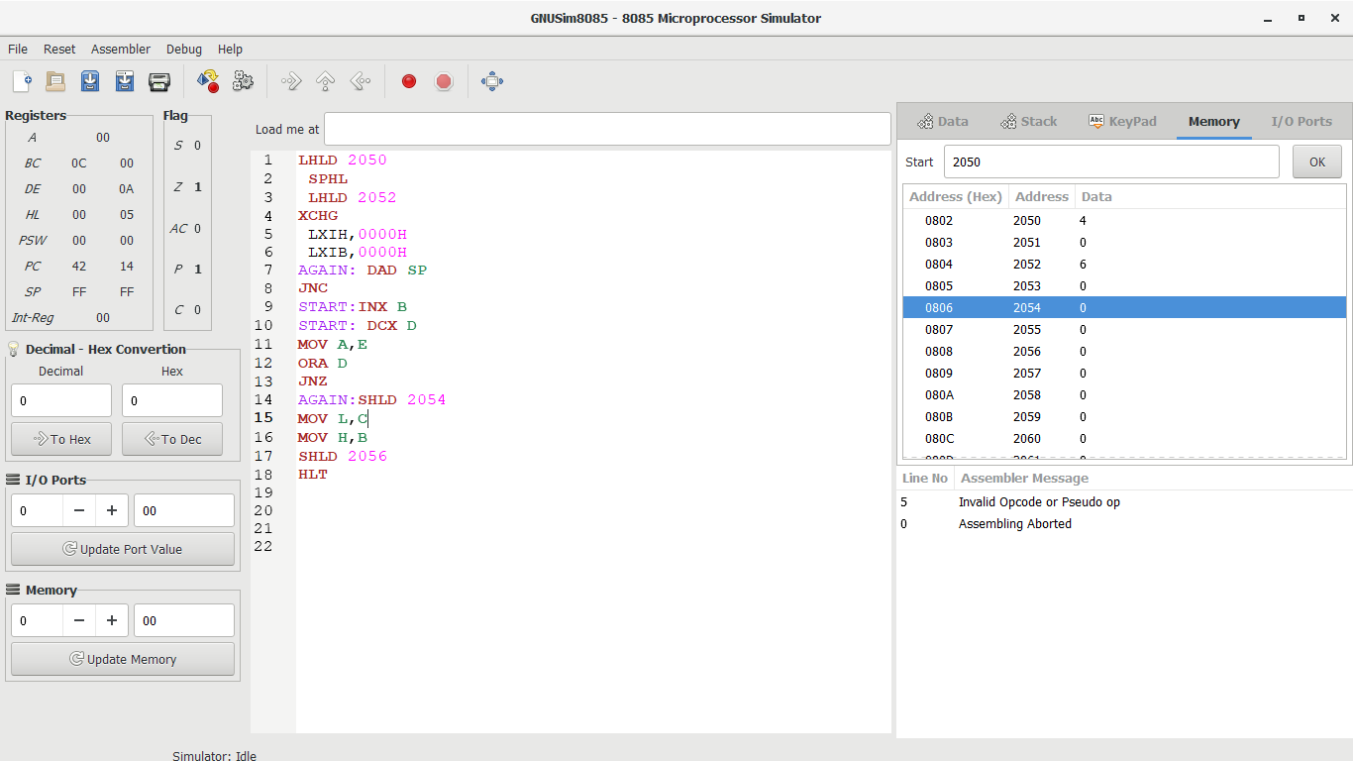  
  
  
  
**OUTPUT:**

  
  
  
  
  
  
**RESULT:**Thus  
the program was executed successfully using 8085 processor simulator.